Subject: DF & IR

TryHackMe Completed Room’s

Intro to Digital Forensics
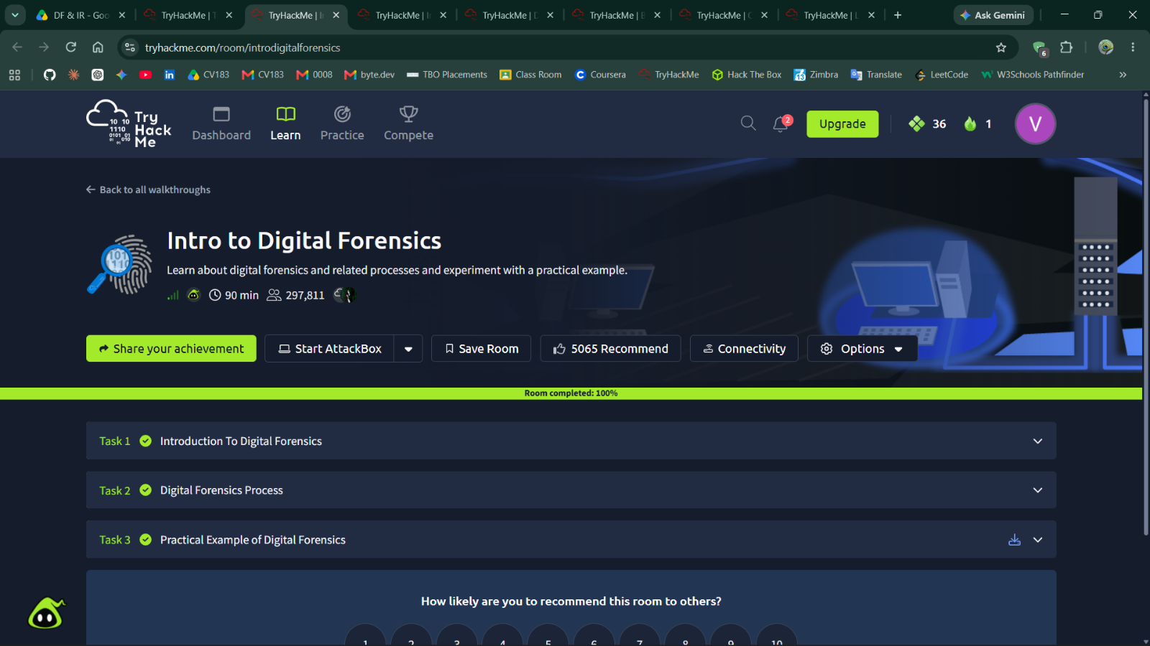

Intro to Cold System Forensics
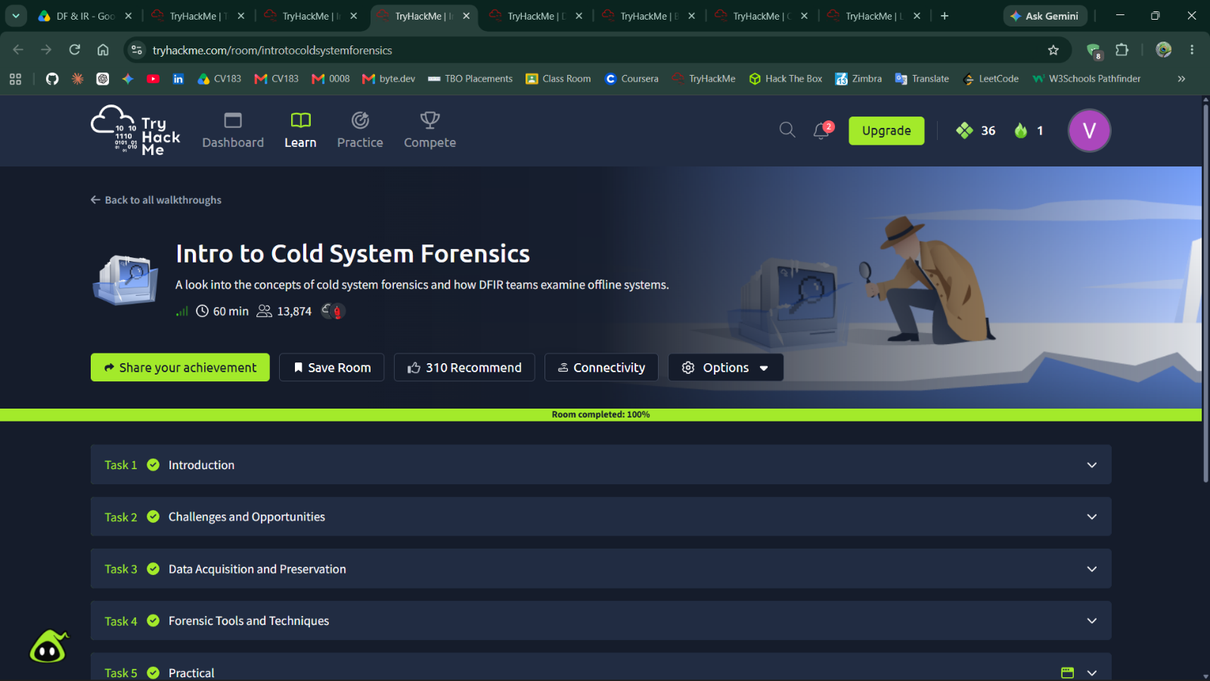

Disk Analysis & Autopsy
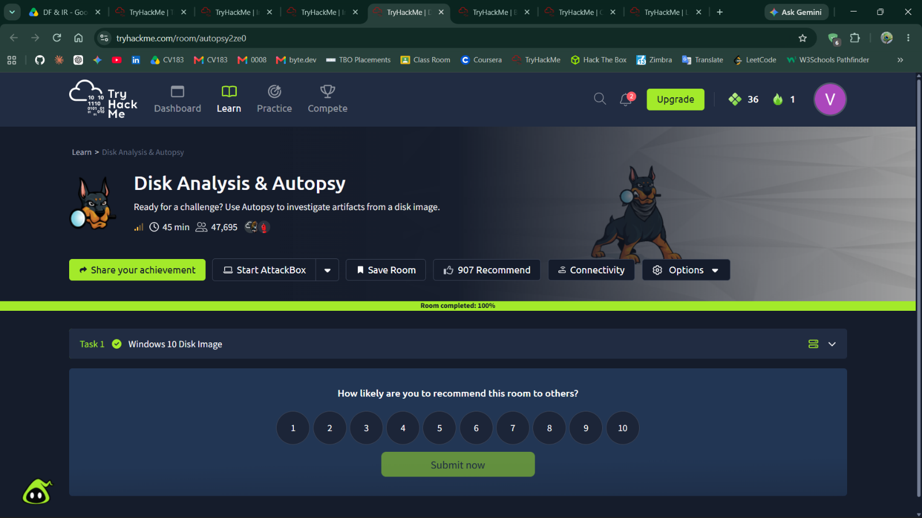

Broken Access Control
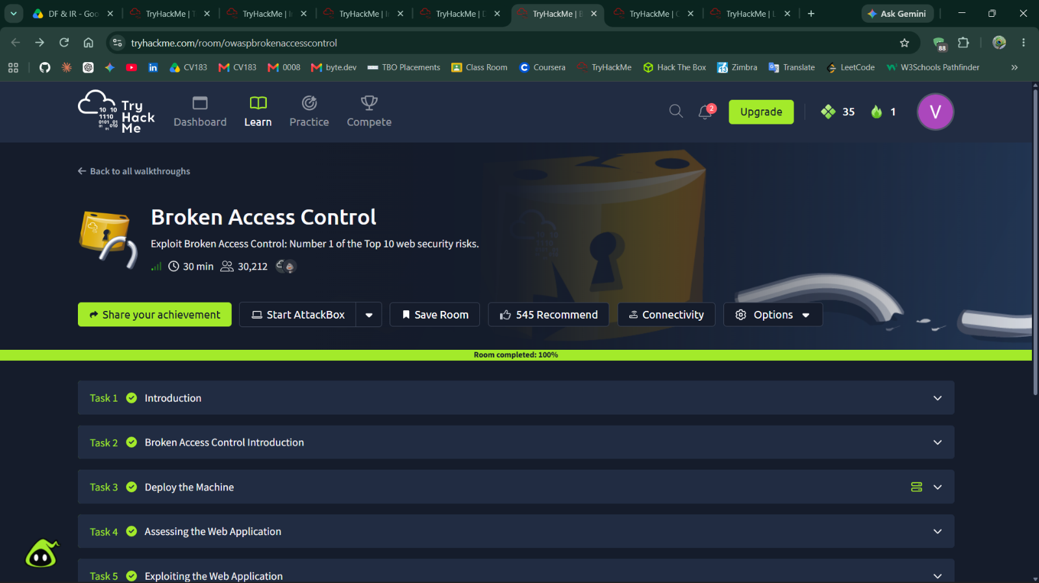

Crack the hash
